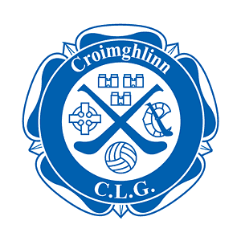

Annual General Meeting
04th November 2021

Nomination for Election to Committee

Nominations AGM 2021
Position | Outgoing | Eligibility
Chairman | Luke Lawlor | Eligible
Vice Chairman | Paul O'Brien | NGF
Secretary | Catherine Fitzgerald | Eligible
Vice Secretary | Laura Gannon | Eligible
Registrar | Martina Hodgins | Eligible
Treasurer | Maurice Kerrigan | NGF
Assistant Treasurer
PRO | Ronan Mooney | Eligible
Child Protection Officer | Will Smyth | Eligible
Insurance administrator | Cathal Hennebry | Eligible
Club Development Officer | Gerard Gavigan | Eligible
Club Development Officer | Stephen Maher | Eligible
Club Development Officer | Michael Cullen | Eligible
Adult Games Officer | Paul Dunne | Eligible
Juvenile Games Officer | Phil Gough | NGF
Female Player Representative
Male Player Representative | Paul Devlin | Eligible
Committee member | Karen Ryan | Eligible

*NGF = Not going forward

Annual General Meeting
04th November 2021
Nomination for Election to Committee

Position being Proposed (tick one only; use separate forms for multiple nominations)

❑ | Chairperson
❑ | Vice-Chairperson
❑ | Secretary
❑ | Assistant Secretary
❑ | Treasurer
❑ | Assistant Treasurer
❑ | Registrar
❑ | Public Relations Officer
❑ | Adult Games Officer
❑ | Juvenile Games Officer
❑ | Child Protection Officer
❑ | Player Representative
❑ | Club Development Officer

Nominee * | Name (Print)
 | *Signature of Nominee (confirm willing to serve)
Proposed By * | Name (Print)
 | *Signature of Proposer
Seconded By* | Name (Print)
 | *Signature of Seconder

